A Comparative Study Between Ciclosporine A Eye Drop (2%) and Tacrolimus Eye Ointment (0.03%) in Management of Children with Refractory Vernal keratoconjunctivitis.
- Mohamed Amin Heikal MD ⁽¹⁾ ⁽²⁾
- Tarek T Soliman,MD⁽¹⁾
- Waleed S Aboseif, MD ⁽¹⁾
- Ahmed A Shebl, MD⁽¹⁾
¹Benha University, Benha city, Qualuopia, Egypt;²Magrabi Eye Hospital, Eastern Province, KSA
Corresponding author: Mohamed Amin Heikal - Department of Ophthalmology - Benha University –Egypt. E-mail: mohammedheikel@gmail.com
The study was performed in Benha University Hospital, Benha , Egypt.

Disclosure statement

This work was self-funded by the authors

No conflicts of interest to declare
Data availability statement
The data of patients used to support the findings of this study are restricted by the (Benha Hospital research ethics board). Data are available for researchers who meet the criteria for access to confidential data upon request from assistant professor Mohamed Amin Heikal - Department of Ophthalmology - Benha University –Egypt. E-mail: mohammedheikel@gmail.com
Key words: Ciclosporin A, Tacrolimus, VKC
Abstract
Purpose: To compare the effects of both Ciclosporine A (2%), and tacrolimus (0.03%) eye ointment on children with VKC, who are not responding to corticosteroids eye drops.
Methods: A prospective comparative study carried out on children who were diagnosed as refractory VKC at the ophthalmology clinic (tertiary center) in Benha university, Delta area, Egypt in the period from October 2019 to February 2020, with follow up at least 6 months after beginning of treatment.
Results: Fifty-nine patients completed this study. The mean age of Ciclosporin A group was 10.83 ± 4.74 years (Range 4-17 years) and it was 9.96± 4.16 years (Range 3-18 years) in Tacrolimus group. The mean basal symptoms score significantly reduced from 15.35 ± 3.23to 11.32 ± 3.97 (p<0.001) at the first week, to 2.73 ± 3.18 (p<0.001) at 4 weeks and to 2.26 ± 4.29 (p<0.001) at 12-week in the ciclosporin A group. While in the tacrolimus group, it significantly reduced from 15.02 ± 2.81to 12.09 ± 3.48 (p<0.001) at the 1st week, to 1.88 ± 2.63 (p<0.001) at 4th week and to1.04 ± 2.55 (p<0.001) at 12th week.
No statistical significance difference was detected between both groups at each visit (p>0.05).
As regard the individual symptom score, redness and burning sensation showed statistically significant reduction in tacrolimus group than Ciclosporine A group at the first week visit(P=0.001and0.028).
Regarding the total signs score, there was reduction in the mean basal score in the tacrolimus group more than the Ciclosporine A, but this reduction did not reach the statistical difference at any visit. However, Tacrolimus group had significantly lower mean scores for tarsal conjunctival papillary hypertrophy at the 1st week and 12th week (P 0.027 and 0.018 respectively), punctate erosion at the 1st week (P 0.028) and cobble stone papillae at the 1st week (P 0.001).
Failure of treatment was seen in 6 patients (21.4%) in Ciclosporin group and 5 patients (16%) in Tacrolimus group after 3 months of cessation of drug. No serious side effect was detected in any group.
Conclusion: Although there was no statistically significant difference between both groups regarding the improvement of the inflammatory symptoms and signs after treatment, the study showed a good satisfaction and more compliance with tacrolimus eye ointment. Long term medication for refractory cases was advised to control inflammation. Ciclosporin A eye drop and Tacrolimus eye ointment could be considered as corticosteroid sparing drugs in management of children with refractory VKC.
Introduction:
Vernal kerato-conjunctivitis (VKC) is a severe chronic form of seasonally exacerbated allergic conjunctivitis which affects mainly children and young people.^{1,2} A significant incidence of VKC in children was reported in Egypt. ³
VKC is considered as a type 1 hypersensitivity reaction, with IgE-mediated mast cell activation. Recent studies have reported that it may be an ocular surface disease.^{4,5}
Several drugs are currently used to treat VKC, including antihistamines, mast-cell stabilizers, dual-acting agents, corticosteroids, and immunomodulators or immunosuppressants. ^{1,6}
Topical steroids are the most effective drugs to control the signs and symptoms of VKC.⁷ Potential side effects of long-term use of steroid drugs like, ocular hypertension, glaucoma, cataract, and secondary infections are reported. ⁶
Ciclosporine A is an important drug in treatment of refractory VKC cases, as it inhibits T cells proliferation and prevents the release of proinflammatory cytokines by blocking the activity of calcinerurin, a ubiquitous enzyme found in cell cytoplasm that is implicated in the control of replication of the genes for IL-2 and other pro- inflammatory cytokines.^{8,9} Topical Ciclosporine A treatment also has an advantage in that it lacks the serious adverse ocular effects often seen with topical corticosteroids.⁹

Tacrolimus is like Ciclosporine A in its mode of action, but 100-fold greater potency. Topical 0.03% Tacrolimus ointment is a safe and effective treatment for steroid- resistant refractory VKC; however, long-term use is needed to control the disease. ¹⁰
We aim to compare the effects of both Ciclosporine A (2%), and tacrolimus (0.03%) eye ointment on children with VKC, who are not responding to corticosteroids eye drops.
Methods:
This is a prospective comparative study carried out on children who were diagnosed as refractory VKC at the ophthalmology clinic in Benha University, Delta area, Egypt in the period from October 2019 to February 2020, with follow-up at least 3 months after the beginning of treatment. All subjects provided informed written consent for participation. The patients considered refractory VKC if their symptoms and signs persisted despite applying prednisolone 1% 5 times for 4 to 6 weeks.
Patients with best-corrected visual acuity 20/40 or less than in any of both eyes without a justifying cause; a history of taking systemic NSAIDs, systemic steroidal anti-inflammatory drugs, systemic immunosuppressants; and who are in an active stage of any other ocular inflammatory disease were excluded.
A higher basal sign score in one eye was selected for comparison unless the score was equal in both eyes; we have chosen the right eye. The Institutional Review Board (IRB) and Research Ethics Committee of Ophthalmic Department, Benha University approved the study. The study adhered strictly to the tenets of the Declaration of Helsinki (the 2013 revision).
The patients were randomized into 2 groups according to the specific received drug. The randomization was simple with an equal allocation ratio through computer-generated random number:
Group A: Received Ciclosporine A 2% in artificial tears in a dosage of one drop every 6 hours in both eyes during the 12 weeks of the study.
Group B: Received the Tacrolimus eye ointment (0.03%) every 12 hours in both eyes during the 12 weeks of the study.
All patients were evaluated by the same investigator in the initial period and subsequent programmed follow-up visits. Consequently, on baseline visit and each follow-up visit, a tolerance questionnaire was applied using a verbal analog scale starting from 0 to 3 with increasing intensity of symptoms (itching, redness, watering, discharge, burning, and photophobia) and signs (Palpebral conjunctival hypertrophy, conjunctival injection, cobblestone papillae, limbal inflammation and punctate epithelial erosion) were recoded according to table 1. ^{11, 12}
Examination:
The basal examination (day 0 of the study) was carried out 7 days before day 1 of the study. In this visit, the patients and their parents were asked to sign the informed consent and to stop any medication that can interfere with the results of the study, up to 48 hours before day 1 of the study.
Demographic information, clinical history, and specific symptoms were obtained. A complete ophthalmic examination including best-corrected visual acuity (BCVA) determination (Snellen chart), slit lamp biomicroscopy, intraocular pressure (IOP) measurement (Goldmann applanation tonometer), and dilated fundus examination was conducted. Follow-up visits on 1st week, 4th week and 12th week were scheduled.
On each follow-up visit, a complete ocular examination was performed and the scores of the symptoms and signs were recorded and compared with other visits.
The primary outcome measure of our study was the reduction of the total symptoms and signs scores. The secondary outcome measures were changes in the score of individual symptoms and signs, side effects, visual acuity, and mean intraocular pressure.
Failure of treatment was considered if symptoms and signs of inflammation persisted despite compliance with medications.

Preparation of 2% Ciclosporine A ophthalmic solution:
- Each ml of sandimmune (Neoral 50 ml) syrup containing 100 mg Ciclosporine A was diluted by artificial tears (Tears Natural Tears) to make 2 % Ciclosporine A ophthalmic solution (5 ml).^{13,14}
- After enrollment of patients and recording their symptoms and signs, each patient was instructed to instill one drop of the 2% Ciclosporine A ophthalmic solution into each affected eye four times daily during waking hours for 12 weeks.

Tacrolimus:
- Tacliment 0.03% eye ointment produced by Aurolab Indian Company.¹⁵
- Statistical analysis: Data were analyzed by SPSS statistical package version 23 (SPSS Inc. Released 2015. IBM SPSS statistics for windows, version 23.0, Armnok, NY: IBM Corp.), and were expressed in number (No), percentage (%) mean (Mean), and standard deviation (SD). Student’s t-test was used for quantitative variables between two groups of normally distributed data, while Mann Whitney's test was used for not normally distributed ones. Repeated measures ANOVA (with or without Bonferoni correction) with Mauchly test for sphericity test were used for comparison among three or more consecutive measures in the same group of quantitative variables. Assumed sphericity was used for normally distributed data while Greenhouse-Geisser was used for not normally distributed data. Two-sided P- value of < 0.05 was considered statistically significant.
Results:
Eighty-seven consecutive VKC children presented to our institute in the period from October 2019 to February 2020 were eligible to participate in this study. Nineteen patients who had irregular or lost their follow-up, were excluded. Fifty-nine patients completed this study. The mean age of group A was 10.83 ± 4.74 years, and it was 9.96± 4.16 years in group B. The difference in the mean age of both groups was statistically insignificant (p=0.454). Most of the patients were male. They presented 83.9% of group A and 82.1% of group B (Table 2).
All the patients used some form of treatment for VKC before enrollment (topical antihistaminic, 59 patients (100%) and mast cell stabilizers, 45 patients (76.3%)). Limbal VKC was the most common form of presentation; 13 (41.9%) cases in group A and 17 (60.7%) cases in group B, followed by tarsal type VKC; 8(25.8%) cases in group A and 7(25%) cases in group B, and mixed VKC; 8 (25.8%) cases in group A and 6 (21.4%) cases in group B.
The mean basal symptoms score significantly reduced from 15.38 ± 2.3 to 11.41 ± 3.5 (p<0.001) at the first week, to 2.96 ± 2.84 (p<0.001) at the 4th week and to 2.26 ± 4.29 (p<0.001) at the 12th week in the Ciclosporine A group. While in the tacrolimus group, it significantly reduced from 15.03± 2.06 to 9.6 ± 2.99 (p<0.001) at 1st week, to 1.85 ± 1.93 (p<0.001) at the 4th week, and to10.92± 1.35 (p<0.001) at the 12th week.
As comparing the mean symptoms scores between baseline and follow-up visits, there was a statistically significant difference (p<0.05). No statistically significant difference was detected between both groups at each visit (p>0.05). Table 3
Regarding individual symptom score; redness, burning, photophobia, and foreign body sensation showed a statistically significant reduction in tacrolimus group than Ciclosporine A group at the 1st week visit (p<0.001). While there was a statistically significant reduction in tacrolimus group regarding burning and foreign body sensations at the 4th week, and redness and burning sensation at the 12th week than ciclosporine A group. Table 4
Regarding the total signs score, there was reduction in the mean basal score in the tacrolimus group more than the Ciclosporine A, but this reduction did not reach the statistical difference at any visit ((p<0.001). In addition, the Tacrolimus group had significantly lower mean scores for tarsal conjunctival papillary hypertrophy at the 1st week and the 12th week (P 0.037 and 0.046 respectively), punctate erosion at the 1st week (P 0.029), and cobblestone papillae at the 1st week (P 0.037). Although there was no statistically significant difference between both groups regarding cobblestone at the 12th week, there was a complete reduction of cobblestone in the tacrolimus group. Table 5 and table 6
The palpebral conjunctival lesion started to improve from the first week in all groups, but relapse was seen in severe forms in both groups after 3 months during their follow -up.
Relapse of symptoms and signs (failure of treatment) was seen in 6 patients (21.4%) in group A and 5 patients (16%) in group B after 3 months of cessation of the drug. All of them were severe according to their scored symptoms and signs at the time of presentation, and they were treated with additional topical corticosteroids. The mean intraocular pressure at baseline and follow-up visits is shown in table 7.
The stinging sensation was detected in all patients that were treated with Ciclosporine A that persist for 10 minutes after application of the treatment, but it was not recorded in the tacrolimus group. No serious side effect was detected in any group.
Discussion:
The study showed a significant reduction in the total symptoms and signs scores of children with refractory VKC to corticosteroid, that had received Ciclosporine A (2%), and Tacrolimus eye ointment (0.03%) for 3 months comparing with the baseline. The Success of treatment was seen in 79% of patients in the Ciclosporine A group and 84% of patients in the tacrolimus group. No significant side effects were detected in any group.
Long-standing VKC causes corneal scarring, shield ulcer, keratoconus, irregular astigmatism, and cataract, leading to visual impairment and subsequent school absence. ^{2, 13, 14}
However topical corticosteroids are effective drugs for treating VKC, cataract formation, and development of glaucoma are common side effects of long-term application. ^{2,12}
Topical ciclosporin A and Tacrolimus are alternative therapies for VKC to reduce corticosteroid usage or for corticosteroid-refractory cases. ^{10,16-20}
Topical Ciclosporine A 0.05, 0.1,1 and 2% have been tried for VKC treatment in previous studies. ^{7,18 21,22}
Our study showed that the effectiveness of Ciclosporine A 2% is significant enough at the 1st week, while Labcharoenwongs et al demonstrated the improvement within one month. ²³
Pucci and his colleagues found the application of topical 2% Ciclosporine A for 4 weeks resulted in a significant reduction in the symptoms and signs of VKC cases .¹⁸
Tatlipinar et al concluded that 2% Ciclosporine A is effective as topical dexamethasone in the management of children VKC. ²⁰
Spadavecchi et. al reported that application of Ciclosporine A 1% and 1.25% for 4 months achieved more reduction of subjective and objective scores .⁷
The variation in the response is due to the variation of the concentration of the drug; higher concentration leads to rapid response in a short period.
There are previous studies that evaluated the effect of tacrolimus on VKC patients.
They used either eye drop^{24,25} or eye ointment^{11,23} with different concentrations (0.005,0.03 and 0. 1%).^{11,23,24,25} They found dramatic response and improvement of inflammatory symptoms and signs ^{11,23-25}
In our study, there was a statistically significant improvement in the tacrolimus group as compared with Ciclosporine A regarding redness, burning, photophobia, and foreign body sensation at the 1st week visit (p<0.001). While there was a significant reduction in tacrolimus group regarding burning and foreign body sensations at the 4th week, and redness and burning sensation at the 12th week; however, at other visits, there was no statistically significant difference between both groups regarding all symptoms p>0.05. To explain that, the form of ointment with long standing effect of tacrolimus eye ointment as comparing with the stinging sensation of the Ciclosporine A application and subsequent decrease in the ocular surface exposure time.
In our study, all symptoms were relieved significantly in both groups within the 1st week (p<0.001), while Kheirkah et al reported that itching was the first symptom to be relieved by tacrolimus drug.²⁵
In the present study, we noticed a statistically significant improvement in the tacrolimus group regarding punctate erosion, tarsal conjunctival papillae hypertrophy, and cobblestone papillae when comparing with Ciclosporine A at the 1st week and conjunctival papillae hypertrophy at the 12th week.
Kymnios et al reported a complete reduction of giant papillae with one month in giant papillae conjunctivitis patients treated with tacrolimus.²⁶ While in our study, there was a complete reduction of cobblestone papillae in the tacrolimus group at 12th week while; In contrast, other studies reported delaying or incomplete reduction of the upper tarsal conjunctival papillae and cobble stone. ^{25,27,28}
There was a reduction in the basal mean TSSS and TOSS from 1st week onwards examined the efficacy of tacrolimus compared to Ciclosporine A with no statistically significant difference between the two groups at any follow-up visits.
In agreement with our study, Labcharoenwongs and his colleagues reported insignificant statistically improvement of signs and symptoms between both groups. They found improvement of objective ocular signs was more with tacrolimus treatment; however, this finding did not reach a significant difference. ²³
No significant ocular side effects in either group were detected. No significant changes in the mean intraocular pressure during the follow-up period were detected.
Treatment failure was observed in 6 cases (21.4%) in ciclosporin A group and 5 cases (16%) in tacrolimus group. Our result is the same as in previous studies. ^{11,25}
We didn’t use ciclosporin A in one eye and tacrolimus in other eye of the same patient because we believe that it may be confusing by the patient to put the drug in the correct eye and subsequent incorrect evaluation by the investigator.
No literature at present mentions the course of the disease after stopping treatment with concerning concentration and duration which needs to be taken care of before reaching to some conclusion. The limitations of our study are small sample size and short-term follow-up.
Conclusion:
Although there was no statistically significant difference between both groups regarding the improvement of the inflammatory symptoms and signs after treatment, the study showed a more reduction of inflammatory symptoms and signs, and compliance with tacrolimus eye ointment. Long term medication for refractory cases was advised to control inflammation. Ciclosporine A eye drop, and Tacrolimus eye ointment could be considered as corticosteroid-sparing drugs in the management of children with refractory VKC.

References
- Leonardi A, Motterle L, Bortolotti M. Allergy and the eye. Clin Exp Immunol. 2008 Sep;153 Suppl 1(Suppl 1):17-21.
- Kiliç A, Gürler B. Topical 2% cyclosporine A in preservative-free artificial tears for the treatment of vernal keratoconjunctivitis. Can J Ophthalmol. 2006 Dec;41(6):693-8.
- Zepeda-Ortega B, Rosas-vargas MA, Ito Tsuchiya FM (2007): Conjuntivitis alérgica en la infancia. Revista Alergia México 54: 41-53.
- Bonini S, Coassin M, Aronni S, Lambiase A. Vernal keratoconjunctivitis. Eye (Lond). 2004 Apr;18(4):345-51.
- Kumar S. Vernal keratoconjunctivitis: a major review. Acta Ophthalmol. 2009 Mar;87(2):133-47.
- Hingorani M, Lightman S. Therapeutic options in ocular allergic disease. Drugs. 1995 Aug;50(2):208-21.
- Spadavecchia L, Fanelli P, Tesse R, Brunetti L, Cardinale F, Bellizzi M, Rizzo G, Procoli U, Bellizzi G, Armenio L. Efficacy of 1.25% and 1% topical cyclosporine in the treatment of severe vernal keratoconjunctivitis in childhood. Pediatr Allergy Immunol. 2006 Nov;17(7) 527-532.
- BenEzra D, Matamoros N, Cohen E. Treatment of severe vernal keratoconjunctivitis with cyclosporine A eyedrops. Transplant Proc. 1988 Apr;20(2 Suppl 2):644-9.
- Avunduk A, M, Avunduk M, C, Erdöl H, Kapicioglu Z, Akyol N: Cyclosporine Effects on Clinical Findings and Impression Cytology Specimens in Severe Vernal Keratoconjunctivitis. Ophthalmologica 2001; 215:290-293.
- Ryu EH, Kim JM, Laddha PM, Chung ES, Chung TY. Therapeutic effect of 0.03% tacrolimus ointment for ocular graft versus host disease and vernal keratoconjunctivitis. Korean J Ophthalmol. 2012 Aug;26(4):241-7.
- Chatterjee S, Agrawal D. Tacrolimus in Corticosteroid-Refractory Vernal Keratoconjunctivitis. Cornea. 2016 Nov;35(11):1444-1448.
- Akpek EK, Dart JK, Watson S, Christen W, Dursun D, Yoo S, O'Brien TP, Schein OD, Gottsch JD. A randomized trial of topical cyclosporin 0.05% in topical steroid-resistant atopic keratoconjunctivitis. Ophthalmology. 2004 Mar;111(3):476-82.
- Chast F, Lemare F, Legeais JM, Batista R, Bardin C, Renard G. Préparation d'un collyre de ciclosporine à 2% [Cyclosporine 2% eye drops preparation]. J Fr Ophtalmol. 2004 Jun;27(6 Pt 1):567-76.
- Fiscella RG, Le H, Lam TT, Labib S. Stability of cyclosporine 1% in artificial tears. J Ocul Pharmacol Ther. 1996 Spring;12(1):1-4.
- Aurolab india company: www.aurolab.com/tacliment_cp.asp
- Secchi AG, Tognon MS, Leonardi A. Topical use of cyclosporine in the treatment of vernal keratoconjunctivitis. Am J Ophthalmol. 1990 Dec 15;110(6):641-5.
- Bleik JH, Tabbara KF. Topical cyclosporine in vernal keratoconjunctivitis. Ophthalmology. 1991 Nov;98(11):1679-84.
- Pucci N, Novembre E, Cianferoni A, Lombardi E, Bernardini R, Caputo R, Campa L, Vierucci A. Efficacy and safety of cyclosporine eyedrops in vernal keratoconjunctivitis. Ann Allergy Asthma Immunol. 2002 Sep;89(3):298-303.
- Daniell M, Constantinou M, Vu HT, Taylor HR. Randomised controlled trial of topical ciclosporin A in steroid dependent allergic conjunctivitis. Br J Ophthalmol. 2006 Apr;90(4):461-4.
- Tatlipinar S, Akpek EK. Topical ciclosporin in the treatment of ocular surface disorders. Br J Ophthalmol. 2005 Oct;89(10):1363-7.
- De Smedt S, Nkurikiye J, Fonteyne Y, Tuft S, De Bacquer D, Gilbert C, Kestelyn P. Topical ciclosporin in the treatment of vernal keratoconjunctivitis in Rwanda, Central Africa: a prospective, randomised, double-masked, controlled clinical trial. Br J Ophthalmol. 2012 Mar;96(3):323-8.
- Yücel OE, Ulus ND. Efficacy and safety of topical cyclosporine A 0.05% in vernal keratoconjunctivitis. Singapore Med J. 2016 Sep;57(9):507-10.
- Labcharoenwongs P, Jirapongsananuruk O, Visitsunthorn N, Kosrirukvongs P, Saengin P, Vichyanond P. A double-masked comparison of 0.1% tacrolimus ointment and 2% cyclosporine eye drops in the treatment of vernal keratoconjunctivitis in children. Asian Pac J Allergy Immunol. 2012 Sep;30(3):177-84.
- Wan Q, Tang J, Han Y, Wang D, Ye H. Therapeutic Effect of 0.1% Tacrolimus Eye Drops in the Tarsal Form of Vernal Keratoconjunctivitis. Ophthalmic Res. 2018;59(3):126-134.
- Kheirkhah A, Zavareh MK, Farzbod F, Mahbod M, Behrouz MJ. Topical 0.005% tacrolimus eye drop for refractory vernal keratoconjunctivitis. Eye (Lond). 2011 Jul;25(7):872-80.
- Kymionis GD, Kankariya VP, Kontadakis GA. Tacrolimus ointment 0.03% for treatment of refractory childhood phlyctenular keratoconjunctivitis. Cornea. 2012 Aug;31(8):950-2.
- Ohashi Y, Ebihara N, Fujishima H, Fukushima A, Kumagai N, Nakagawa Y, Namba K, Okamoto S, Shoji J, Takamura E, Hayashi K. A randomized, placebo-controlled clinical trial of tacrolimus ophthalmic suspension 0.1% in severe allergic conjunctivitis. J Ocul Pharmacol Ther. 2010 Apr;26(2):165-74.
- Fukushima A, Ohashi Y, Ebihara N, Uchio E, Okamoto S, Kumagai N, Shoji J, Takamura E, Nakagawa Y, Namba K, Fujishima H, Miyazaki D. Therapeutic effects of 0.1% tacrolimus eye drops for refractory allergic ocular diseases with proliferative lesion or corneal involvement. Br J Ophthalmol. 2014 Aug;98(8):1023-7.

Table 1: Sociodemographic characters:
Character | Cyclosporin A (n=31)  No. (%) | Tacrolimus (n=28)  No. (%) | P value
Gender  Male  Female | 26 (83.9)  5 (16.1) | 23 (82.1)  5 (17.9) | 1.00
 | Mean ±SD | Mean ±SD
Age (year) | 10.83 ± 4.74 | 9.96 ± 4.16 | 0.454

Table 2: Total mean symptoms score of the studied groups.
Total symptoms score | Cyclosporin A (n=31)  Mean ±SD | Tacrolimus (n=28)  Mean ±SD  median | P value
BASELINE | 15.38 ± 2.30 | 15.03 ± 2.06 | 0.482
Week1 | 11.41 ± 3.50 | 9.60 ± 2.99 | 0.068
Week 4 | 2.96 ± 2.84 | 1.85 ± 1.93 | 0.252
Week12 | 2.09 ± 2.74 | 0.92 ± 1.35 | 0.180
Pair wise P value | P1 <0.001  P2 <0.001  P3 <0.001 | P1 <0.001  P2 <0.001  P3 <0.001
Post-hoc analysis of Total mean symptoms score; P1: Baseline vs week1, P2: Baseline Vs week4, P3: Baseline Vs week12,

Table3: The mean of individual Symptom of the 2 groups:
Symptom |  | Cyclosporin A (n=31)  Mean ±SD | Tacrolimus (n=28)  Mean ±SD | P value
Itching | Baseline | 2.67 ± 0.47 | 2.64 ± 0.48 | 0.781
Itching | Week1 | 2.19 ± 0.40 | 2.25 ± 0.70 | 0.510
Itching | WEEK4 | 0.25 ± 0.44 | 0.46 ± 0.50 | 0.101
Itching | WEEK12 | 0.16 ± 0.37 | 0.35 ± 0.78 | 0.642
Itching | Pairwise p value | P1 <0.001  P2 <0.001  P3 <0.001 | P1 0.002  P2 <0.001  P3 <0.001
Redness | BASELINE | 2.83 ± 0.37 | 2.57 ± 0.50 | 0.099
Redness | WEEK1 | 1.16 ± 0.68 | 0.82 ± 0.0.54 | 0.043
Redness | WEEK4 | 0.74 ± 0.57 | 0.57 ± 0.50 | 0.274
Redness | Week12 | 0.70 ± 0.86 | 0.14 ± 0.35 | 0.005
Redness | Pairwise p value | P1 <0.001  P2 <0.001  P3 <0.001 | P1 <0.001  P2 <0.001  P3 <0.001
Burning | Baseline | 2.45 ± 0.50 | 2.64 ± 0.48 | 0.144
Burning | Week1 | 2.06 ± 0.85 | 1.50 ± 0.74 | 0.016
Burning | Week4 | 0.61 ± 0.61 | 0.28 ± 0.46 | 0.032
Burning | Week12 | 0.38 ± 0.71 | 0.07 ± 0.26 | 0.048
Burning | Pairwise P value | P1 0.031  P2 <0.001  P3 <0.001 | P1 <0.001  P2 <0.001  P3 <0.001
Photophobia | Baseline | 2.48 ± 0.76 | 2.28 ± 0.46 | 0.073
Photophobia | Week1 | 1.93 ± 0.72 | 1.53 ± 0.63 | 0.032
Photophobia | Week4 | 0.32 ± 0.47 | 0.07 ± 0.26 | 0.018
Photophobia | Week12 | 0.29 ± 0.69 | 0.14 ± 0.35 | 0.698
Photophobia | Pairwise P value | P1 <0.001  P2 <0.001  P3 <0.001 | P1 <0.001  P2 <0.001  P3 <0.001
Foreign body sensation | Baseline | 2.67 ± 0.47 | 2.42 ± 0.50 | 0.057
Foreign body sensation | Week1 | 2.06 ± 0.85 | 1.50 ± 0.69 | 0.012
Foreign body sensation | Week4 | 0.61 ± 0.46 | 0.28 ± 0.46 | 0.032
Foreign body sensation | Week12 | 0.38 ± 0.71 | 0.03 ± 0.18 | 0.107
Foreign body sensation | Pairwise P value | P1 <0.001  P2 <0.001  P3 <0.001 | P1 <0.001  P2 <0.001  P3 <0.001
Tearing | Baseline | 2.32 ± 0.47 | 2.64 ± 0.50 | 0.269
Tearing | Week1 | 2.00 ± 0.57 | 2.00 ± 0.60 | 1.00
Tearing | Week4 | 0.41 ± 0.76 | 0.17 ± 0.47 | 0.226
Tearing | Week12 | 0.16 ± 0.37 | 0.17 ± 0.39 | 0.861
Tearing | Pairwise P value | P1 0.004  P2 <0.001  P3 <0.001 | P1 <0.001  P2 <0.001  P3 <0.001

Post-hoc analysis of the mean individual symptom score; P1: Baseline vs week1, p2: Baseline vs week4, p3: Baseline vs week12.

Table 4: The total mean Signs score.
Signs score | Ciclosporine A (n=31)  Mean ±SD | Tacrolimus (n=28)  Mean ±SD | P value
Baseline | 10.80 ± 2.34 | 10.17 ± 1.80 | 0.483
Week1 | 9.32 ± 2.44 | 7.89 ± 1.74 | 0.054
Week4 | 3.32 ± 2.11 | 2.39 ± 2.54 | 0.242
Week12 | 1.83 ± 2.16 | 0.82 ± 1.30 | 0.088
Pairwise | P1 <0.001  P2 <0.001  P3 <0.001 | P1 <0.001  P2 <0.001  P3 <0.001
Post-hoc analysis of the total mean Signs score P1: Baseline vs week1, p2: Baseline vs week4, p3: Baseline vs week12.

Table 5: The mean of individual sign of the groups.
Signs |  | Cyclosporin A (n=31)  Mean ±SD  median | Tacrolimus (n=28)  Mean ±SD  Median | P value
Palpebral conjunctival hypertrophy. | Baseline | 1.38 ± 1.30 | 1.25 ± 1.14 | 0.636
Palpebral conjunctival hypertrophy. | Week1 | 1.35 ± 1.27 | 0.60 ± 0.62 | 0.037
Palpebral conjunctival hypertrophy. | Week4 | 0.93 ± 1.06 | 0.57 ± 0.79 | 0.204
Palpebral conjunctival hypertrophy. | Week12 | 0.90 ± 1.13 | 0.28 ± 0.53 | 0.046
Palpebral conjunctival hypertrophy. | Pairwise P value | P1 1.00  P2 <0.001  P3 0.002 | P1 0.033  P2 <0.001  P3 <0.001
Punctate erosions | BASELINE | 2.16 ± 0.68 | 2.00 ± 0.60 | 0.325
Punctate erosions | WEEK1 | 1.41 ± 0.50 | 1.03 ± 0.69 | 0.029
Punctate erosions | WEEK4 | 0.25 ± 0.63 | 0.17 ± 0.39 | 1.00
Punctate erosions | WEEK12 | 0.16 ± 0.37 | 0.17 ± 0.39 | 0.548
Punctate erosions | Pairwise P value | P1 <0.001  P2 <0.001  P3 <0.001 | P1 <0.001  P2 <0.001  P3 <0.001
Hyperemia | Baseline | 2.38 ± 0.91 | 2.46 ± 0.83 | 0.794
Hyperemia | Week1 | 2.25 ± 0.63 | 2.32 ± 0.61 | 0.707
Hyperemia | Week4 | 0.74 ± 0.57 | 0.75 ± 0.44 | 0.845
Hyperemia | Week12 | 0.45 ± 0.76 | 0.28 ± 0.65 | 0.332
Hyperemia | Pairwise P value | P1 1.00  P2 <0.001  P3 <0.001 | P1 1.00  P2 <0.001  P3 <0.001
Cobblestone papillae | Baseline | 2.41 ± 1.20 | 2.28 ± 0.93 | 0.121
Cobblestone papillae | Week1 | 2.09 ± 1.13 | 1.64 ± 0.95 | 0.037
Cobblestone papillae | Week4 | 0.54 ± 0.50 | 0.35 ± 0.48 | 0.144
Cobblestone papillae | Week12 | 0.12 ± 0.42 | 0.00 ± 0.00 | 0.094
Cobblestone papillae | Pairwise P value | P1 0.004  P2 <0.001  P3 <0.001 | P1 <0.001  P2 <0.001  P3 <0.001
Limbal inflammation | Baseline | 2.45 ± 1.12 | 2.17 ± 1.02 | 0.082
Limbal inflammation | Week1 | 2.19 ± 1.077 | 2.28 ± 0.97 | 0.821
Limbal inflammation | Week4 | 0.83 ± 0.37 | 0.78 ± 0.68 | 0.541
Limbal inflammation | Week12 | 0.19 ± 0.47 | 0.14 ± 0.44 | 0.565
Limbal inflammation | Pairwise P value | P1 0.110  P2 <0.001  P3 <0.001 | P1 0.498  P2 <0.001  P3 <0.001
Post-hoc analysis of the mean individual sign score; P1: Baseline vs week1, p2: Baseline vs week4, p3: Baseline vs week12,

Table 6: The mean IOP of the studied groups:
IOP | Ciclosporine A (n=28)  Mean ±SD | Tacrolimus (n=31)  Mean ±SD | P value
Baseline | 14.13 ± 1.60 | 14.11 ± 2.23 | 0.965
1 week | 14.71 ± 1.53 | 14.25 ± 1.87 | 0.305
Week 4 | 14.61 ± 1.49 | 14.46 ± 2.06 | 0.751
Week12 | 14.71 ± 1.86 | 14.29 ± 2.38 | 0.454
Pairwise p value | P1 0.174  P2 0.567  P3 0.391 | P1 1.00  P2 1.00  P3 1.00

Figure (1): A patient with mixed VKC. Large cobble - stone papillae and hyperemia are apparent before tacrolimus 0.03% ointment treatment
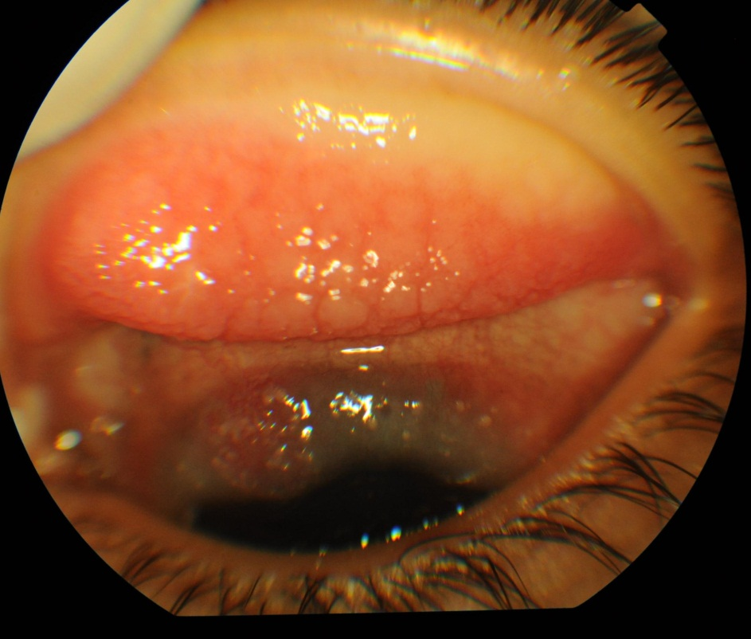

.

Figure (2): The same patient with mixed VKC after 12 weeks of tacrolimus 0.03% ointment treatment showing disapparence of hyperemia and reduction of papillary size.
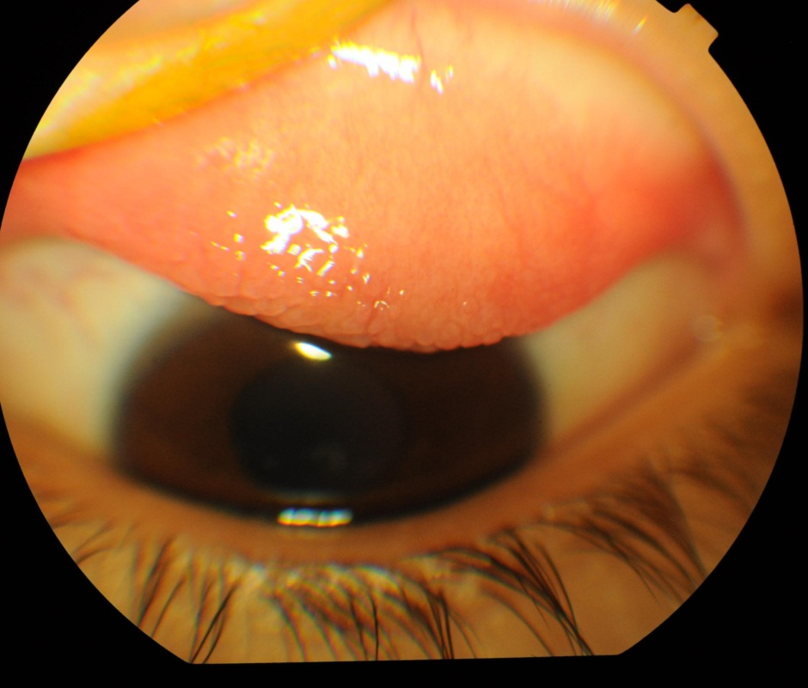

Figure (3): A patient with palpebral VKC. Large cobble - stone papillae and hyperemia are apparent before Ciclosporine A 2% artificial tears treatment.

Figure (4): The same patient with mixed VKC after six weeks of Ciclosporine A 2% caster oil treatment showing decrease of hyperemia and mild decrease of papillary size.

Table 1: Scoring of Ocular Symptoms and Signs11
Scores | 0 | 1 | 2 | 3
Symptoms
Itching | No need to rub the eyes | Occasional need to rub the eyes | Frequent need to rub the eyes | Constant need to rub the eyes
Redness | Absent | Detected only on close  observation | Detected from near | Detected from far
watering | Normal tear production | Watery sensation but no spilling  of tears | Intermittent, infrequent spilling  of tears | Constant/nearly constant spilling  of tears
discharge | No discharge | Small amount of mucoid  discharge in lower cul-de-sac | Moderate amount of mucoid  discharge in the lower  cul-de-sac | Eyelids tightly matted, requiring  frequent cleaning
Burning | Absent | Mild | moderate | Severe
photophobia | Absent | Intolerance to sunlight but can  open the eyes | Intolerance to sunlight such that  cannot keep the eyes open for  long time | Intolerance to sunlight resulting  in avoidance and inability to  open the eyes at all
Signs
Tarsal conjunctival hypertrophy | No evidence of papillae  formation | Mild papillary hyperemia | Moderate papillary hypertrophy  with edema of the palpebral  conjunctiva | Severe papillary hypertrophy  obscuring the visualization of  the deep tarsal vessels
Congestion | None to few dilated  blood vessels | Dilatation of some blood vessels | Dilatation of many blood vessels | Diffuse dilatation
Limbal inflammation | Absent thickening/no  Tranta dots | Thickening with ,1/2 limbus  with/without few Tranta dots | Thickening .1/2 limbus but not  whole with/without many  Tranta dots | Thickening of entire limbus with/  without many Tranta dots
Punctate erosion | Absent | Few scattered or 1 quadrant | More than 1 quadrant but fine | Diffuse or coarse Superficial  punctate keratitis
Cobble stone papillae | No evidence of  cobblestone formation | Few cobblestones | Many cobblestones | Numerous cobblestones

